Server-Side RAD

Order Tracking System

1 Description 3

2 Requirements 3

3 Marks 3

4 Submission 3

5 Skeleton 3

6 Functionality 4

6.1 Main Screen 4

6.2 List Products 5

6.3 Add New Product 6

6.3.1 Success Conditions 6

6.3.2 Invalid user input conditions 7

6.4 List Customers 8

6.5 Add New Customer 9

6.5.1 Success Conditions 9

6.5.2 Invalid user input conditions 11

6.6 List Orders 12

6.7 Add New Order 13

6.7.1 Success Conditions 13

6.7.2 Business Logic for Order Creation: 15

6.7.3 Invalid user input conditions 16

6.8 Security 18

6.8.1 Logout 18

# Description

Write a Spring Boot MVC application that allows a logged-in user to manage orders of products for customers.

# Requirements

The application should be written in Spring Boot based on the skeleton application available on Moodle, and should use the Spring MVC n-tier architecture – Controllers, Services, Repositories, Views, with the appropriate data/logic in each tier.

The Model for the application consists of three objects:

* Product
  + Product ID
  + Description
  + Quantity In Stock
* Customer
  + Customer ID
  + Customer Name
* Order
  + Order ID
  + Order Quantity
  + Order Date

These models have been given in the skeleton code for the project and their dependencies already set up.

# Marks

This project is worth 50% of the marks for the module.

# Submission

A zipped file containing the source code of the entire application should be uploaded to Moodle before 5:00pm on Friday April 28th 2017.

# Skeleton

The application should be created by updating the skeleton application available on Moodle.

# Functionality

## Main Screen

When the application starts, the user should see the following screen:

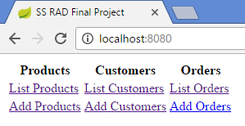

Figure Main Screen

## List Products

This screen shows the list of Products in the sales database:

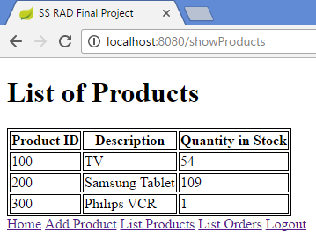

Figure List Products

## Add New Product

This screen allows the user to add a new Product.

### Success Conditions

If all information is entered correctly, the sales database is updated with the new product information:

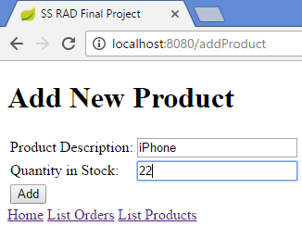

Figure Add New Product – OK

And the user is immediately brought to the List Products page, where the product just entered is shown:

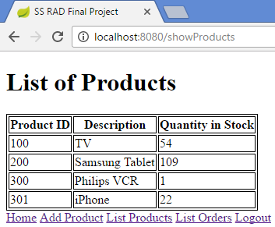

Figure List of Products after new product added

### Invalid user input conditions

If the product description is blank, or the quantity in stock is less than 0 (assume it will always be a number – never blank or a string) the following errors should be displayed, and no product should be added to the sales database.

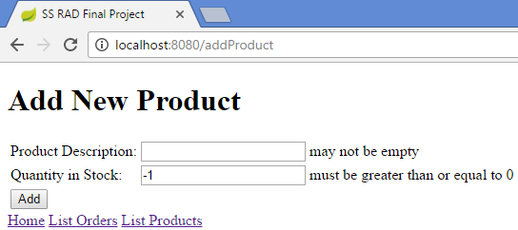

Figure Add New Product – NOK

## List Customers

This screen shows the list of Customers in the sales database.

Underneath each Customer is the list of orders they have placed, if any.

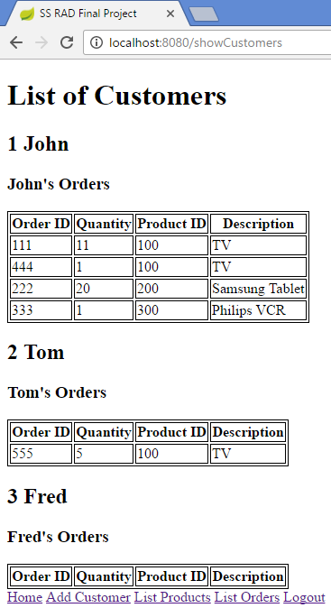

Figure List of Customers

## Add New Customer

This screen allows the user to add a new Customer.

### Success Conditions

If all information is entered correctly, the sales database is updated with the new customer information:

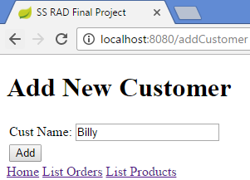

Figure Add New Customer – OK

And the user is immediately brought to the List Customers page, where the customer just entered is shown:

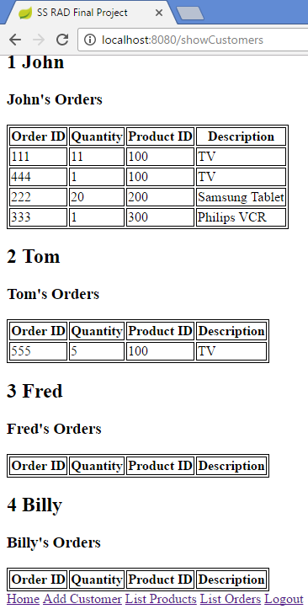

Figure List of Customers after new customer added

### Invalid user input conditions

If the customer name is blank the following error should be displayed, and no customer should be added to the sales database.

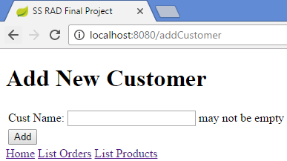

Figure Add New Customer – NOK

## List Orders

This screen shows the list of Orders in the sales database, together with the name of the customer who placed the order and the name of the product that was ordered.

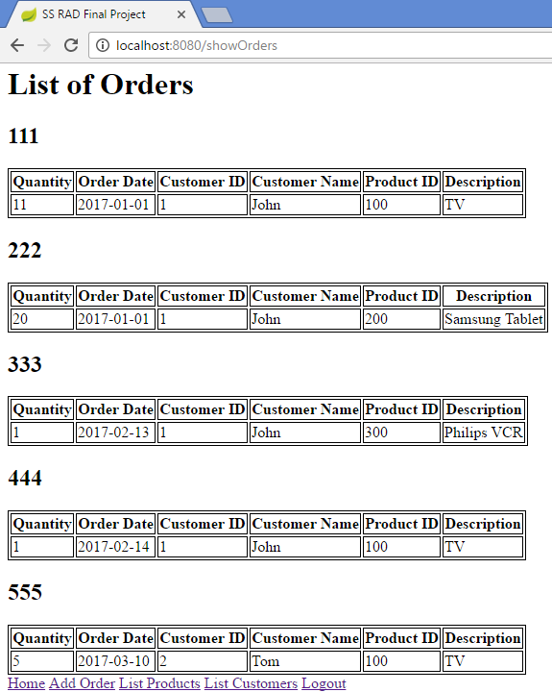

Figure List of Orders

## Add New Order

This screen allows the user to add a new Order.

### Success Conditions

If all information is entered correctly, the sales database is updated with the new customer information:

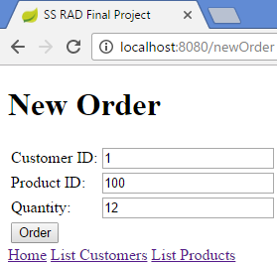

Figure New Order - OK

And the user is immediately brought to the List Orders page, where the order just entered is shown:

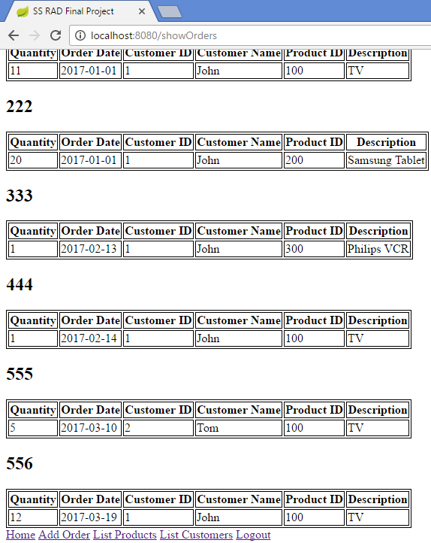

Figure List of Orders after new order added

### Business Logic for Order Creation:

* The Order date (the current date) is automatically inserted by the application – the user does not have to enter the date.
* The Product table is updated to reflect the new quantity. I.e.

Quantity in Stock = (Quantity in Stock *minus* Order Quantity).

In the above example, the Order Quantity for Product 100 was 12 (see Figure 11 New Order - OK).

Before the order was placed the Quantity in Stock for Product 100 was 54 (see Figure 4 List of Products after new product added).

After the order was placed the Quantity in Stock for Product 100 will be 42 (54 – 12).

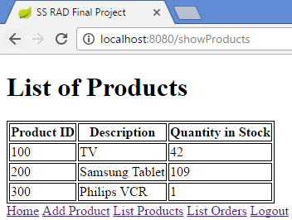

Figure List of Products updated after successful order

* If the user enters a Quantity for an order greater than the Quantity in Stock the following error page should be displayed:

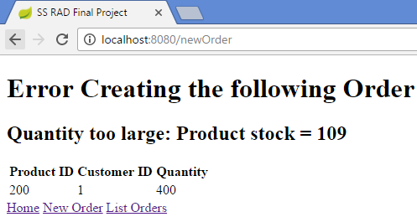

Figure Order Quantity too large error

### Invalid user input conditions

If the Order Quantity is less than 1 (assume it will always be a number – never blank or a string) the following errors should be displayed, and no product should be added to the sales database.

(Assume the Customer ID and Product ID will never be blank)

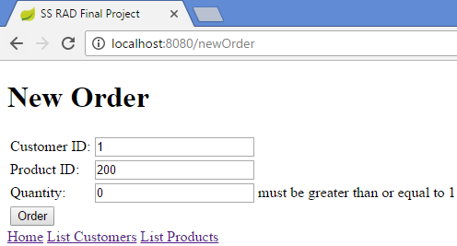

Figure Order Quantity < 1 error

If an invalid Customer ID and/or Product ID is entered, the following page should be shown to the user:

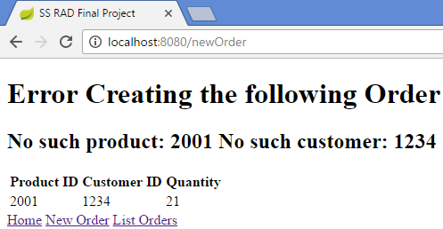

Figure Invalid Customer ID and Product ID

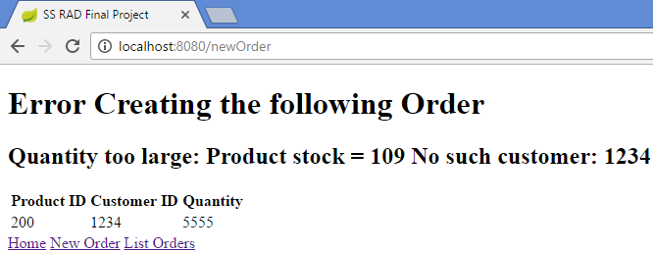

Figure Invalid Customer ID and Product Quantity too large error

## Security

The application should implement security so that unless a user is logged in they will not be able to navigate to any URL.

The only page they should be able to see is the index.html:

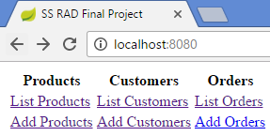

Figure index.html always accessible

If user has not logged in and they attempt to access any of the applications URL endpoints, they should be presented with the following form allowing them to log in:

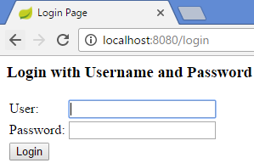

There should be one user (user) with password user.

### Logout

There should be a logout button on the List Customers screen (see Figure 6 List of Customers).